A000-Mex-Chinesco-Warrior with Helmet and Club Protecting Shaft Tomb-Terracotta-300 BCE-300 CE

[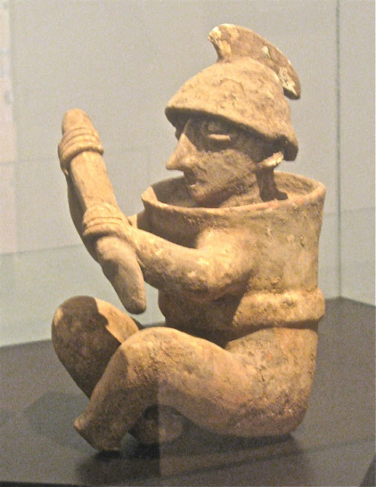](http://4.bp.blogspot.com/-Pm3JMDwLYeo/TwIHSbcNdEI/AAAAAAAAHpM/LO8yb7J7sB0/s1600/M-warrior.jpg)

Mex-Chinesco-Warrior with Helmet and Club Protecting Shaft Tomb-Terracotta-300 BCE-300 CE

**Case no.: 10**

**Accession Number:**

**Formal Label:** Chinesco (Nayarit)–Standing Male with Cap-Clay-Post Conquest-1540 CE

**Display Description:**

**Warrior from Shaft Tomb near Etzatlán.** The warrior wears a crested helmet, possibly of wood or wicker. Around his body he wears wicker armor, shaped like a cylinder. In his hands he brandishes a club or a short spear. A large replica of this warrior stands guard over the entrance road to Etzatlán from Highway 4. The stance, weapon and armor of the warrior are similar to many found through out the area of the Shaft Tombs. The number of warrior figures found, and the level to which they were armed and armored, indicates that this period in Western Mexico was not entirely peaceful. Figs. 1-2. Chinesco (Nayarit)–Standing Male with Cap-Clay-Post Conquest-1540 CE

**LC Classification:**

**Date or Time Horizon:**

**Geographical Area:**

**Map:**

**GPS coordinates:**

**Cultural Affiliation:**

**Media:**

**Dimensions:**

**Weight:**

**Condition:**

**Provenance:**

**Discussion:**

The Western Mexico shaft tomb tradition or shaft tomb culture refers to a set of interlocked cultural traits found in the western Mexican states of Jalisco, Nayarit, and, to a lesser extent, Colima to its south. Built beneath house platforms, these tombs served as family mausoleums and were periodically opened to inter the recently deceased. These two ceramic figures are fine representations of the Nayarit style known as Chinesco, notable for smooth burnished surfaces and painted ornament. These contrast with the heavy three-dimensional costumes and jewelry worn by figures in another local style, the Ixtlán del Río style. This late example roughly dates to 1540 CE when European traits such as the white face and the black cap, gray mustache and brown shoes are exhibited. This figure clearly shows how the local Chinesco people used the European traders for their own purposes as this example was used as a pouring vessel on the eating table of the deceased. The encrustations are dessicated remains of the fluids that were part of the interment process.

**References:**

Shaft tomb burials in West Mexico. After https://upload.wikimedia.org/wikipedia/commons/thumb/d/d3/Ancient_Western_Mexico_Archaeological_Sites.svg/350px-Ancient_Western_Mexico_Archaeological_Sites.svg.png

This Pre-Classic Nayarit (Chineswco) standing male figurine, 5 in. high, is wearing a cap and a stubby mustache, perhaps indicating his rôle as an interloper from Spain post Conquest. He has been used as a pouring device as he has a top loading opening and a spout coming from his right chest area. His face has been painted in a d in a cream slip, and a waistband also painted in a cream slip. The arms are well proportioned and his feet display shoes., Since this figure accompanied the deceased in a shaft tomb burial, it suggests that the importance of this figurine was to assist the interred in his journey to the after-life by being spiritually aware of his transfiguration. Figures similar to this are illustrated in Kan, Meighan and Nicholson 1989: pl. 17, p. 81, also see p. 27.

References:

Kan, Michael, Clement Meighan, H. B. Nicholson. 1989*. Sculpture of ancient west Mexico: Nayarit, Jalisco, Colima. A catalogue of the Proctor Stafford Collection at the Los Angeles County Museum of Art*. Albuquerque: Los Angeles County Museum of Art in association with University of New Mexico Press.